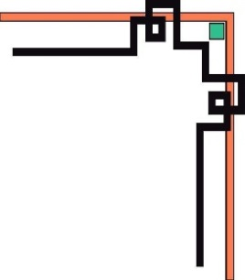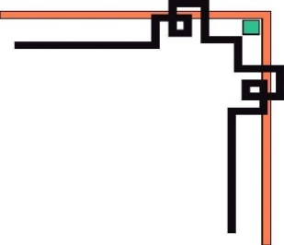

**DANANG SOFTWARE CORPORATION**

**SOFTECH-APTECH**



EProject :

Kids-zone

Guiding faculty : TRINH THI THUY TIEN

Members :

* Nguyen Tien Hien
* Tran Duc Viet
* Nguyen Dang Thanh Dat
* Vo Khanh Duy

Group: 02

Batch: 153

Project Document

**KIDS-ZONE**

|  |  |
| --- | --- |
| **Group 2** | |
| **Instructor** | Ms.Trinh Thi Thuy Tien |
| **Group Members** | Nguyen Tien Hien  Tran Duc Viet  Nguyen Dang Thanh Dat  Vo Khanh Duy |
| **Batch** | 135 |
| **Semester** | 1 |

**TEACHER’S EVALUATION**

**Table of Contents**

I. ACKNOWLEDGEMENTS 5

II. INTRODUCTION 6

III. PROBLEM DEFINITION 6

**1.** **Homepage** 6

**2.** **Product detail page** 6

**3.** **About Us Page** 7

**4.** **Contac Us Page** 7

**5.** **Contact / Feedback** 7

IV. CRS & SITE MAP 7

1. Customer Requirement Specification (CRS) 7

2. Use case diagram 9

V. TECHNICAL 20

VI. REFERENCES 21

VIII. CHECK LIST 28

1. Check List of Validation 28

2. Submission Checklist 28

X. PROJECT PLANNING 30

# I. ACKNOWLEDGEMENTS

We would like to sincerely acknowledge the kindness of all the people who have given moral support and helped us make a successful project.

We wish to express our deep gratitude to the e-Project Team at the Head office, who guided and helped us. Particular thanks to **Ms.Trinh Thi Thuy Tien** who suggested the “form validation” and help us connect storage to our project, develop the analysis proceeding from it and debugged code. We also would like to express our great gratitude to all the student members of our center (Softech Aptech).

Although we have made many attempts, because of the limited time, the practice could not be able to avoid the mistakes and missions. We hope that our project will be considered and evaluated. And finally, we would like to offer many thanks to all our friends for their valuable suggestions and constructive feedbacks.

# II. INTRODUCTION

The www.kids-Zone website is designed for the Kids (Toddlers) for Learning ABC’s in more creative way. The website includes the ABC with A for …., B for….

Also it includes some nursery rhymes with images so that child can grasp more easily. One two three till 100 with and without spellings, some basic calculation of addition and subtraction. Prayers, Galleries of basic animals, plants, fruits, games colors, Sunday-Mondays and so on.

# III. PROBLEM DEFINITION

1. **Homepage**

This is the page where the user will be navigated after a successful access in website. This page is display course products.

On each course product, customer can see a view course detail. The parents comments about kidszone service quality and courses are included.

The home page also shows parents' evaluation of kids-zone, achievements and Gallery of kidszone

Finally, information of Kids-zone address, customer service and policies are display at footer.

1. **Product detail page**

When toddler want start a courses, they can click button “start”. This page includes images, videos, audio that show content of courses.

Learning English page shown: Alphabet, vocabulary by subject, and reading and writing of vocabulary. Fairy tales include audio and text of the story. English songs with links from youtube.com.

Learning Math page show: images number 1-10, images, illustration images calculation addition and subtraction, exercise button links to the calculation practice page, images number 1-100 with video guide count 1-100.

Activites page show guide pray, brush teeth, drink milks by videos

1. **About Us Page**

This page introduces our philosophy, our mission, our vission, our Teachers, Our Program, Parents, and our Certified Teachers

1. **Contac Us Page**

This page includes Kids-zone address and its location on google map. Customers can send their message to Kids-zone through Contact form.

1. **Contact /** **Feedback**

The development of technology era today, social network is a biggest social networks. Our website has functions connected with Facebook, YouTube, Twitter, etc… to help customers connect information and comment easily and faster.

# IV. CRS & SITE MAP

## Customer Requirement Specification (CRS)

* **Client:** Toddler
* **Business/Project Objective**:

The traditional education way is not convenient for busy parents. Therefore, it is necessary to build an online website for to the Kids (Toddlers) for Learning ABC’s in more creative way.

We created kidszone website includes some nursery rhymes with images so that child can grasp more easily. One two three till 100 with and without spellings, some basic calculation of addition and subtraction. Prayers, Galleries of basic animals, plants, fruits, games colors, Sunday-Mondays and so on..

## Use case diagram

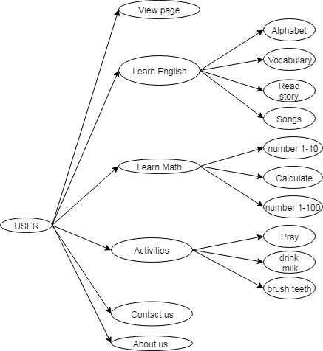

## Use Case Specification

|  |  |  |  |
| --- | --- | --- | --- |
| **USE CASE SPECIFICATION** | | | |
| **Use-case No.** | UC01 | **Use-case Version** | 1.0 |
| **Use-case Name** | *View Webpage* | | |
| **Purpose:**  Users can view products, parent reviews about the web, Achievements and awards, Gallery.  **Input:**  **Output:** | | | |

|  |  |  |  |
| --- | --- | --- | --- |
| **USE CASE SPECIFICATION** | | | |
| **Use-case No.** | UC02 | **Use-case Version** | 1.0 |
| **Use-case Name** | *View content of Learn English* | | |
| **Purpose:**  A user can view a learning English detail of his choice by selecting theme name. Then can learn by audio video image embedded in the web.  **Input:**  **Output:** | | | |

|  |  |  |  |
| --- | --- | --- | --- |
| **USE CASE SPECIFICATION** | | | |
| **Use-case No.** | UC03 | **Use-case Version** | 1.0 |
| **Use-case Name** | *View content of Learn Math* | | |
| **Purpose:**  A user can view a learning English detail of his choice by selecting theme name. Then can learn by audio video image embedded in the web.  **Input (exercise calculate):**  The user will type the result of the randomly selected calculation within 10.  **Output (exercise calculate):**  The system will display the true or false result of the user input with the calculation | | | |

|  |  |  |  |
| --- | --- | --- | --- |
| **USE CASE SPECIFICATION** | | | |
| **Use-case No.** | UC05 | **Use-case Version** | 1.0 |
| **Use-case Name** | *Contact/Feedback* | | |
| **Purpose:**  If the user wants to send a message or feedback for us then they need to to enter information  **Input:**  The user will enter details in the contact form according to therequired fields. The fields include :  1. Name  2. Email  3. Message  **Output:**  Then the user will get the notification message that the feedback was send successfully and the page is refreshed | | | |

|  |  |  |  |
| --- | --- | --- | --- |
| **USE CASE SPECIFICATION** | | | |
| **Use-case No.** | UC06 | **Use-case Version** | 1.0 |
| **Use-case Name** | *View About us* | | |
| **Purpose:**  Users could see information about the Philosophy, Mission, Teachers, Our Program, Parents, Certified Teachers.  **Input:**  **Output:** | | | |

**Site map**

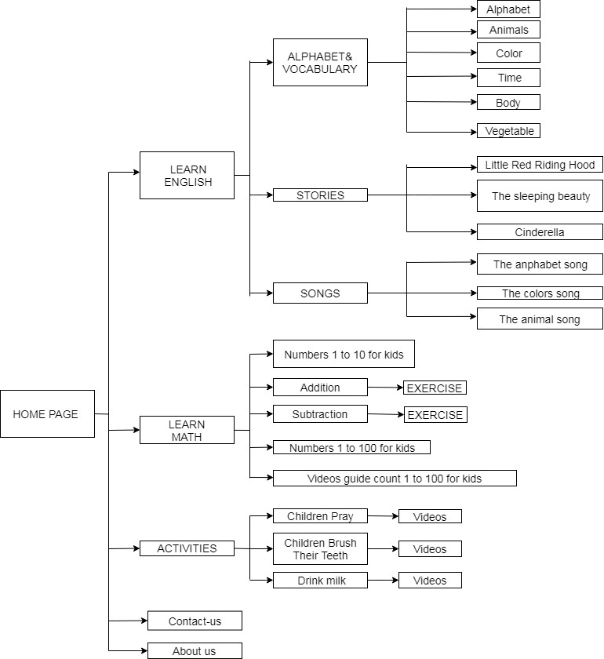

1. **Layout:**

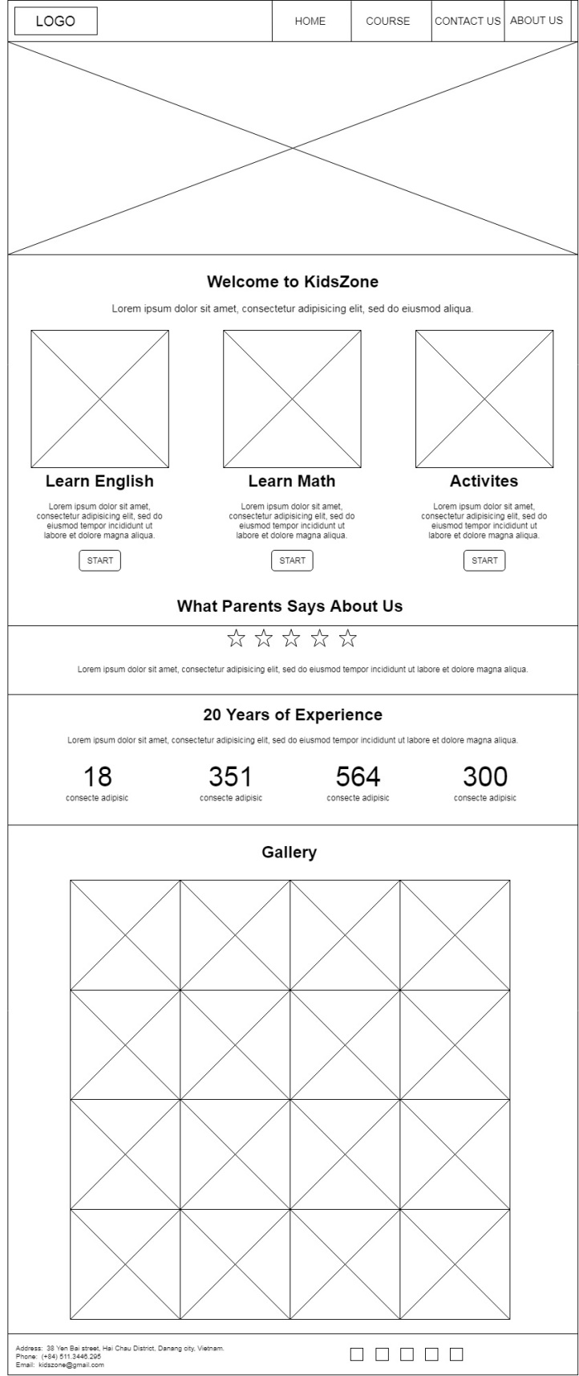

**Layout Home Page**

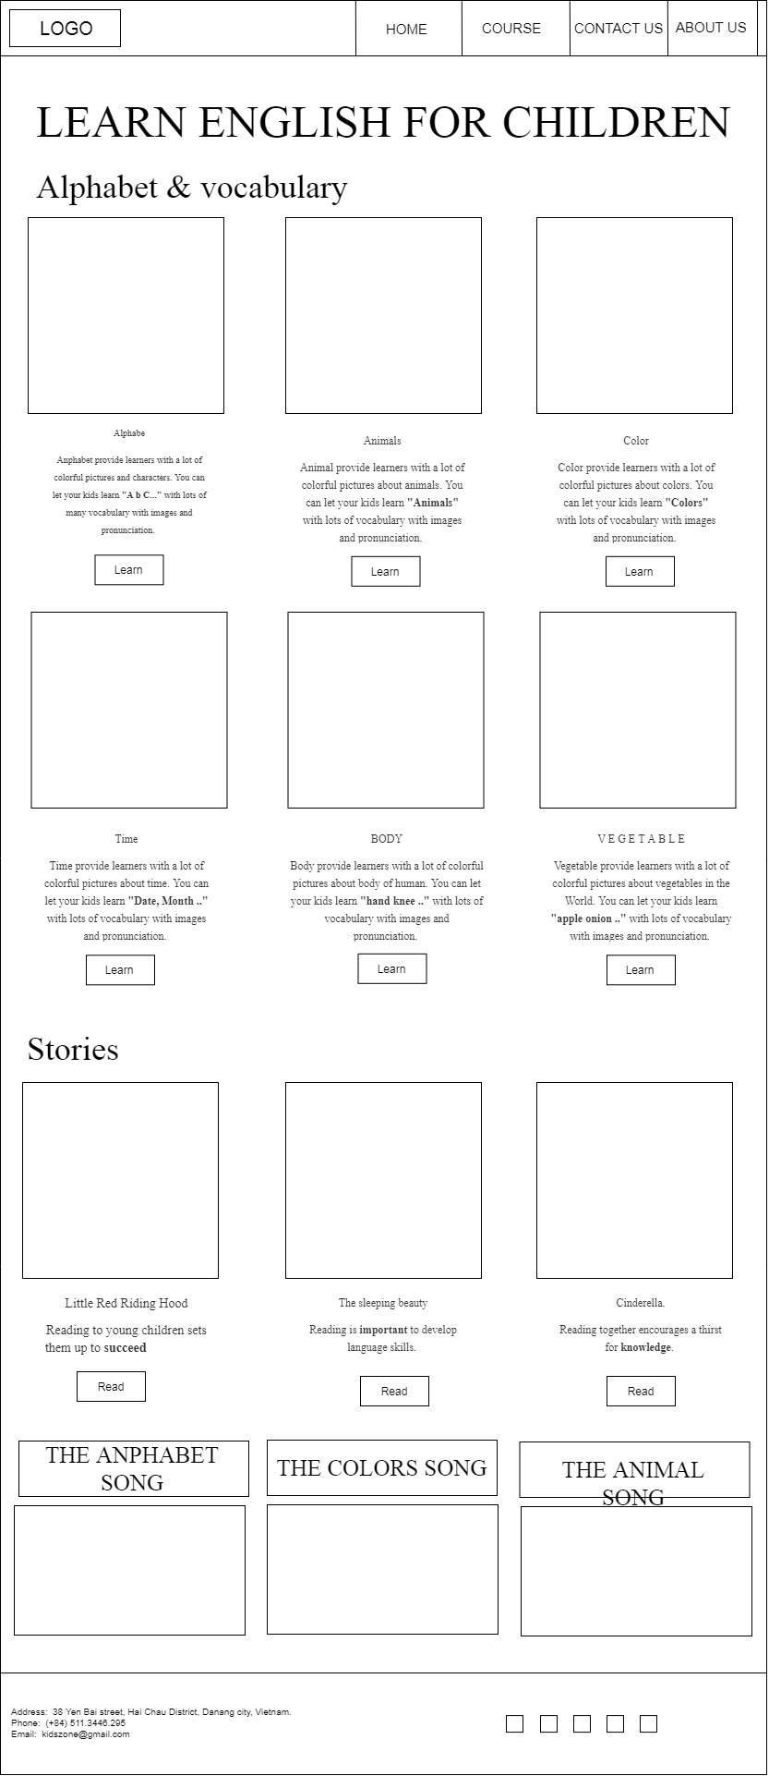

**Layout Learn English Page**

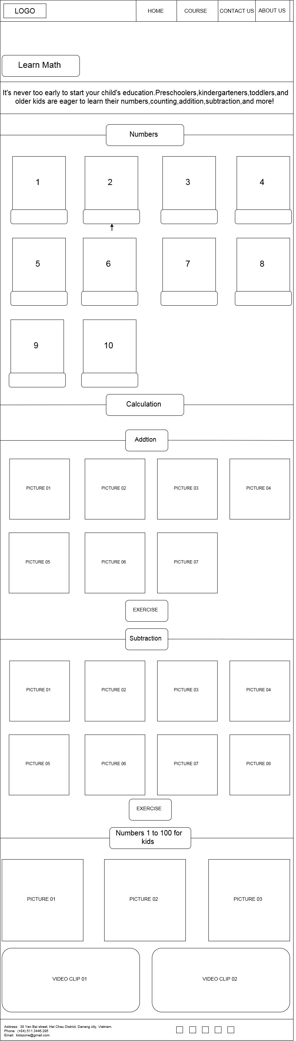

**Layout Learn Math Page**

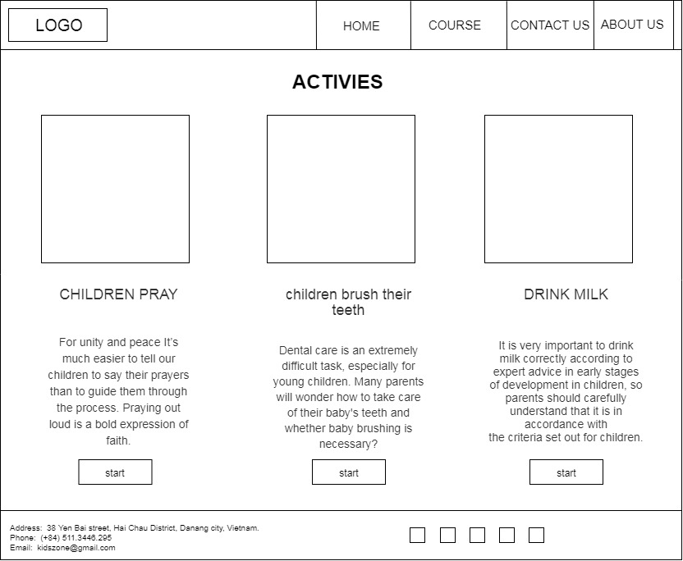

**Layout Activites Page**

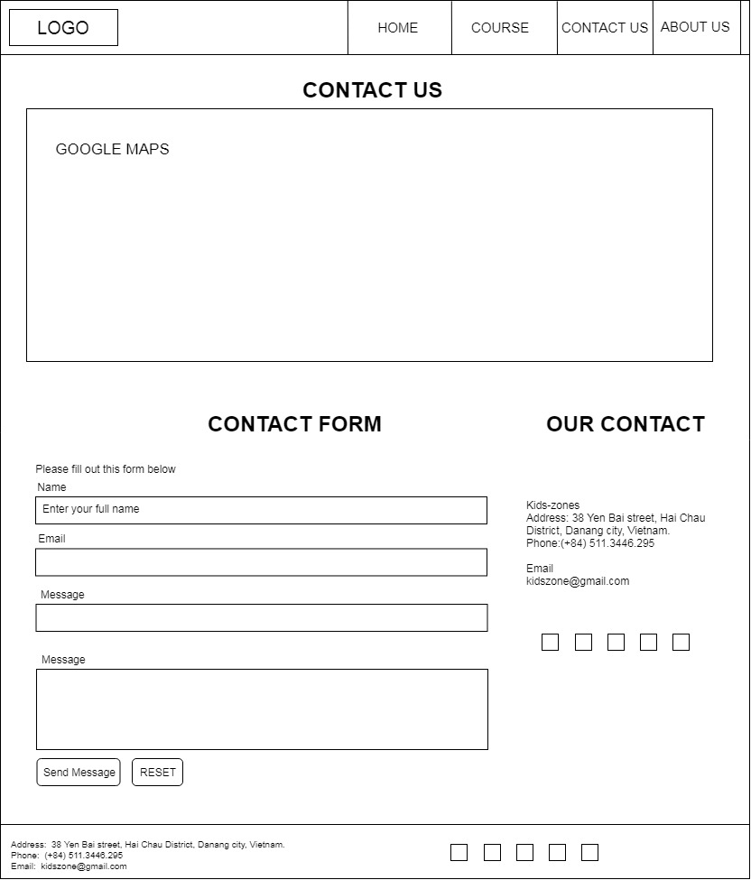

**Layout Contact Page**

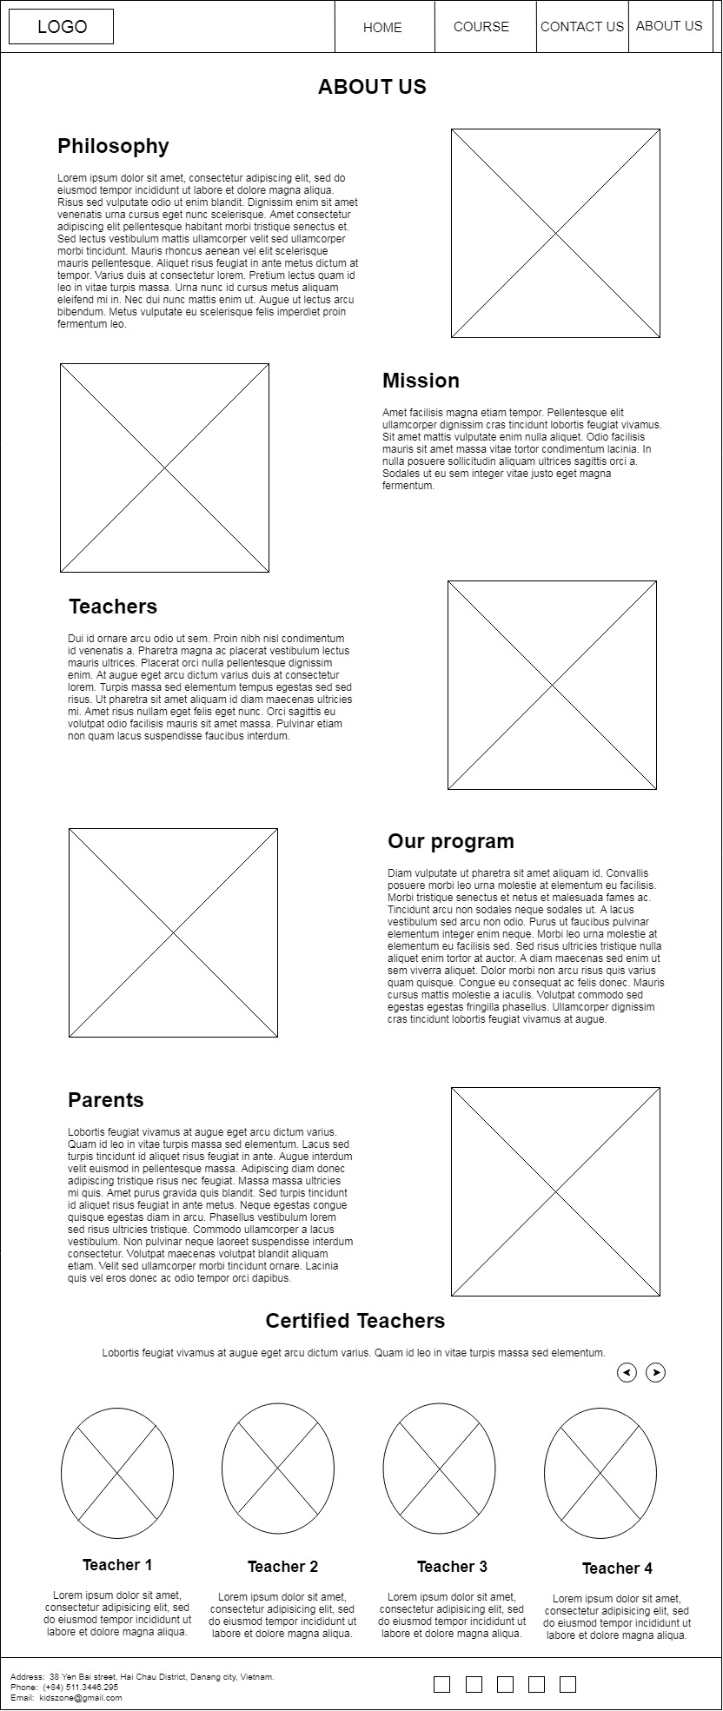

**Layout About us Page**

# V. TECHNICAL

Software: WebStorm

Web Browser: Blisk, Chrome, Firefox support design Responsive

The technique used to build the Website:

* HTML5 & CSS3.
* Responsive Bootstrap
* Validation for bootstrap.
* JQuery & JavaScript.
* Local Storage
* Bootstrap form helpers.
* Horizontal fixed navigation.
* Fancybox JQuery
* Material for bootstrap:
* JS popover.
* JS Scrollspy.
* Tabs.
* BootStrap Carousel.
* Button.
* Form.
* …….
* …….

# VI. REFERENCES

We consulted information on the websites:

* [**https://jquery.com/**](https://jquery.com/)
* [**http://www.w3schools.com/**](http://www.w3schools.com/)
* [**http://www.getbootstrap.com/**](http://www.getbootstrap.com/)

VII. GUI OF WEBSITE

**Home page**

# 

**Learn English page**

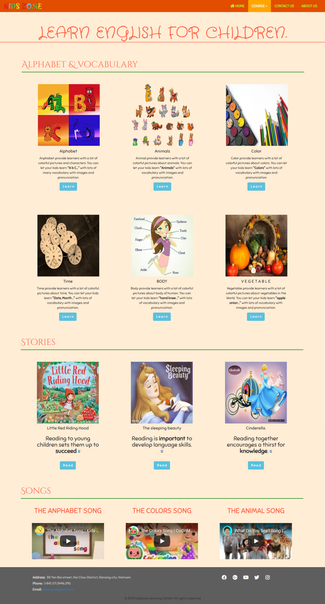

**Learn Math page**

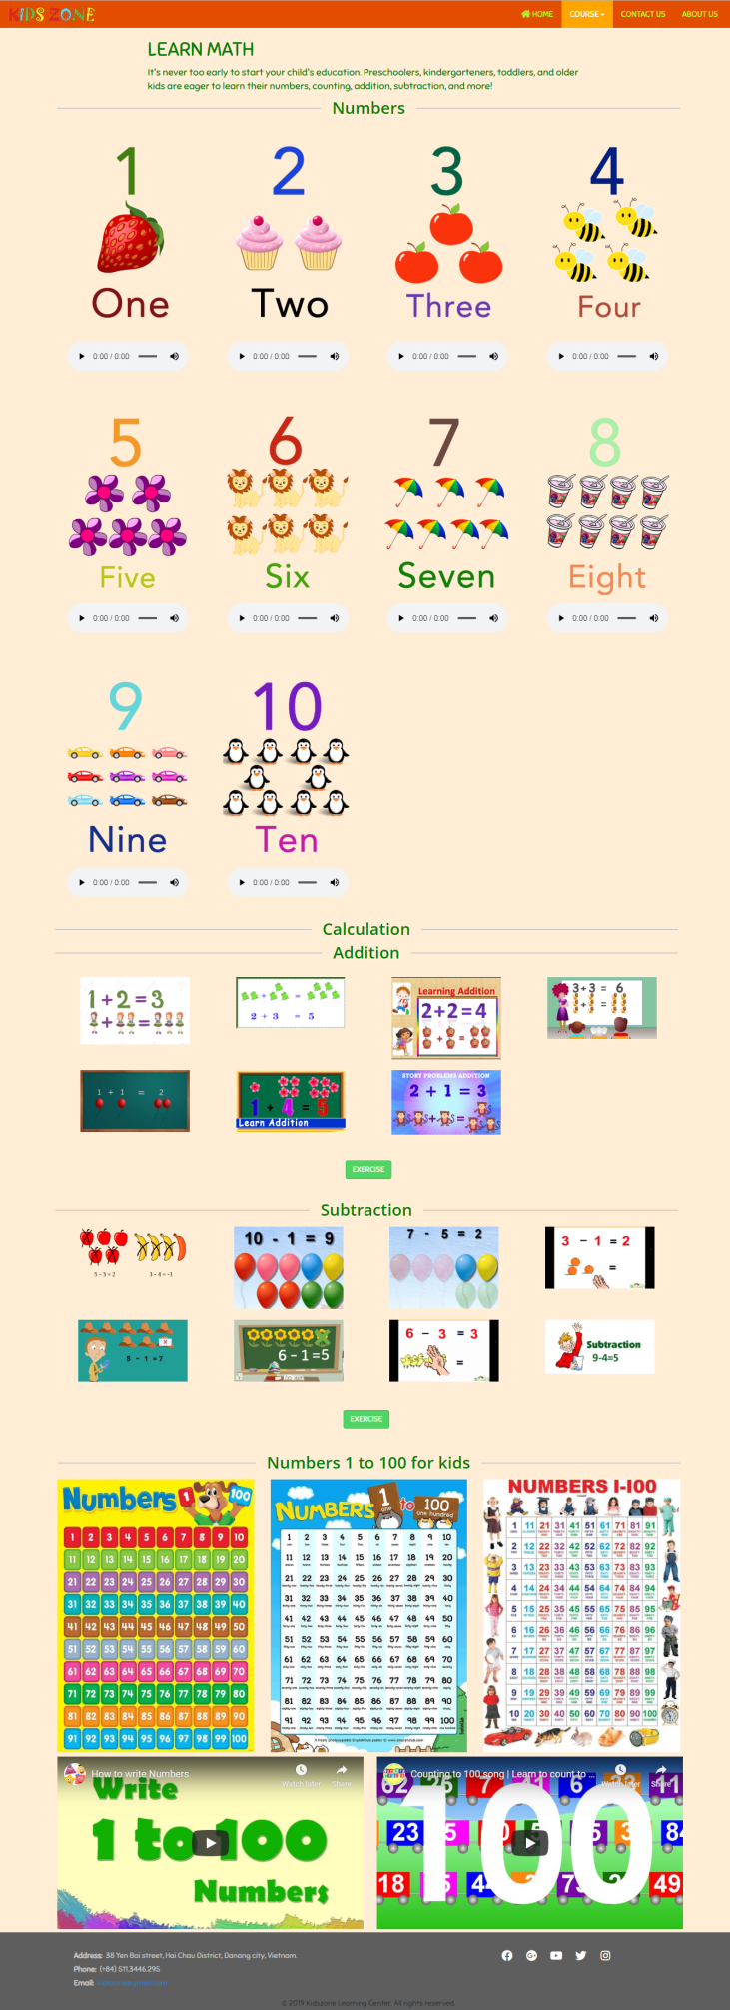

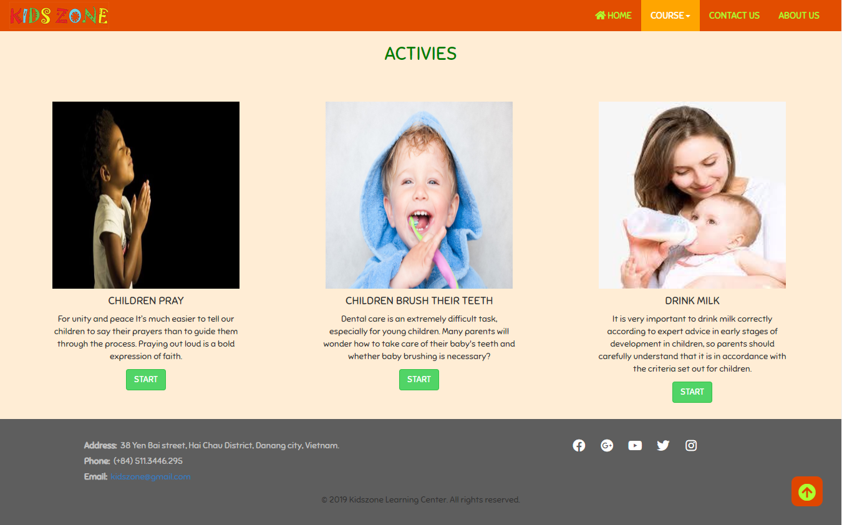

**Activies Page**

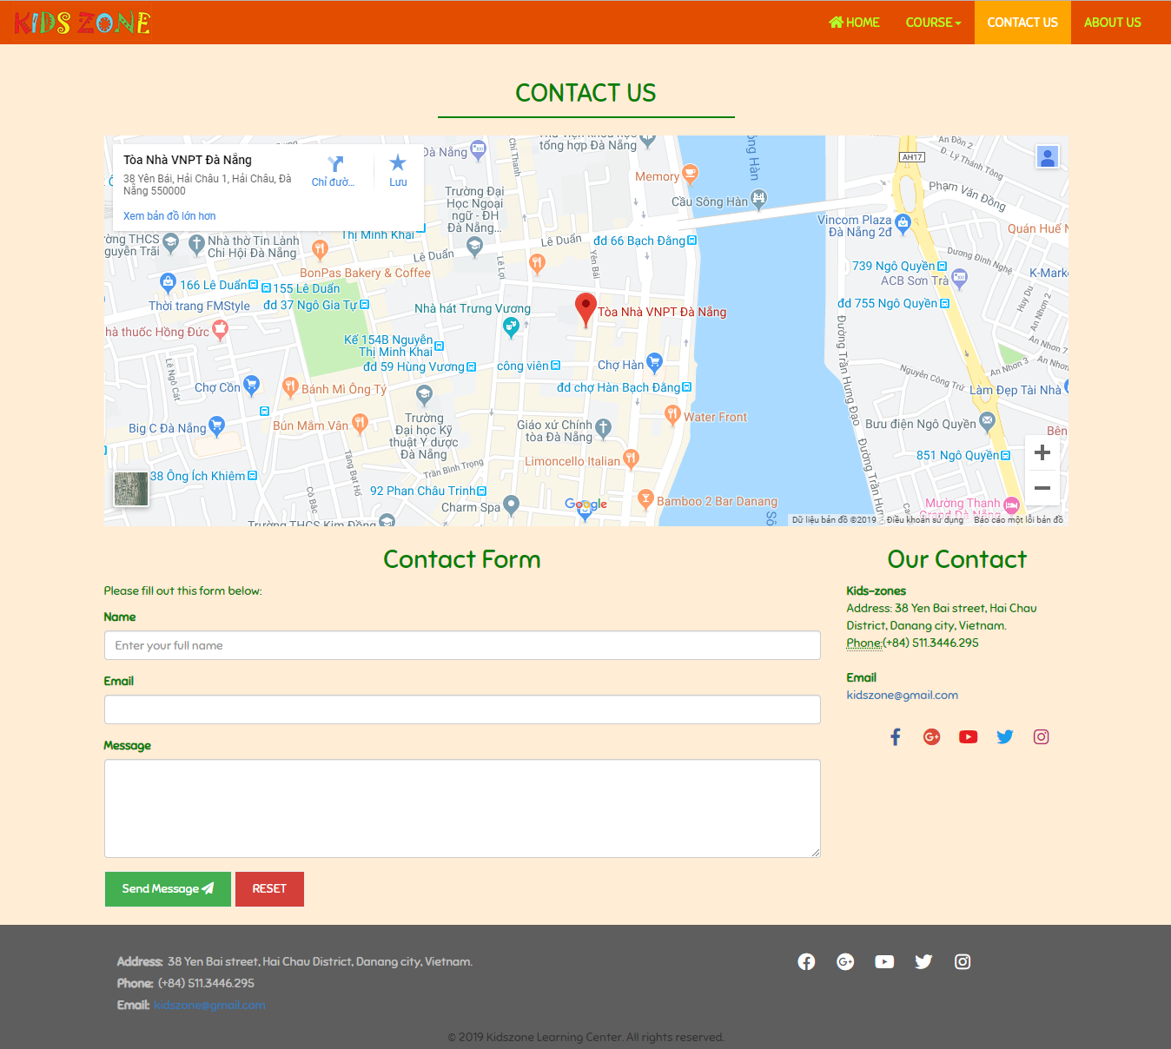

**Contact us pages**

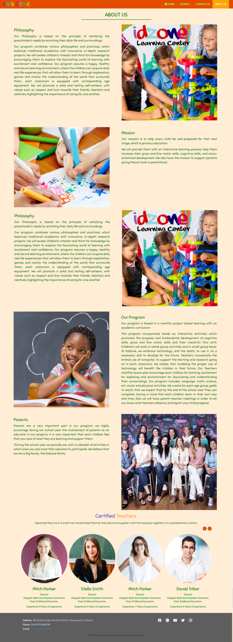

**About Us Page**

# VIII. CHECK LIST

## 1. Check List of Validation

|  |  |
| --- | --- |
| **Option** | **validate** |
| Has the hardware and software been correctly chosen? | Yes |
| Are there functions for the user to enter their comment | No |
| Do all the options present in the application display the correct result? | No |
| Are there functions cart? | No |
| Are there function for the user buy product? | No |

## 2. Submission Checklist

|  |  |  |  |  |  |
| --- | --- | --- | --- | --- | --- |
| **No.** | **Particulars** | **Yes** | **No** | **N/A** | **Comments** |
| 1 | Is the users table to login the Application on the user name and Password? |  | ✓ |  |  |
| 2 | Is there a form for users to enter Personal information when buying Or put item into the cart |  | ✓ |  |  |
| 3 | Can the user to edit employee’s details after getting added? |  | ✓ |  |  |
| 4 | Is the user able to find a product’s wherever they want? |  | ✓ |  |  |
| 5 | Is the application user-friendly? | ✓ |  |  | Windows GUI is familiar with everyone |

**IX. CONCLUTION**

Kidszone website includes: Home page, Learn English, Learn math, Activities, Contact us, About us.

However, this website also need to be develop and upgrated.

Here is the development direction:

1. Complete or perfect remaing parts of this website
2. Change background image and color, font and other as required by the client
3. Develop mobile-optimized website with functions such as: [Website Responsive](https://www.mypage.vn/thiet-ke-web-theo-chuan-mobile.html), [Responsive Design](https://www.mypage.vn/thiet-ke-web-theo-chuan-mobile.html)…
4. Upgrate static website to dynamic website by using java, C#...
5. Build webApp.

# X. PROJECT PLANNING

|  |  |
| --- | --- |
| WORK | MEMBER |
| Navbar | Hien |
| Footer | Hien |
| Home page | Hien |
| Contact page | Hien |
| About page | Hien |
| Learn English page | Duy |
| Alphabet page | Duy |
| All vocabulary page | Duy |
| All read story page | Duy |
| Learn Math page | Viet |
| Exercise Addition page | Viet |
| Exercise Subtraction page | Viet |
| Activities page | Dat |
| Pray page | Dat |
| Brush teeth page | Dat |
| Drink milk page | Dat |